10P Analog Cable, for iTSX and LivewireTS

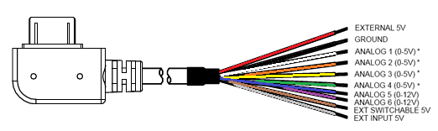

6P Analog Cable, for X3

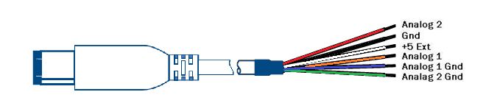

PLX Exhaust Gas Temp Sensor Module
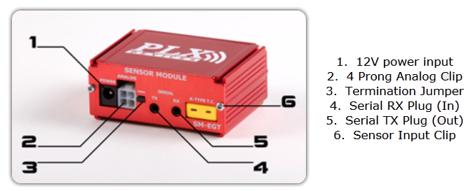
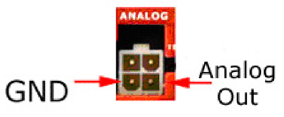
For the 10P analog cable, attach the black wire to the GND on the PLX analog port, and the white wire from the 10P analog cable to the Analog Out on the PLX analog port.
10P iTSX/LivewireTS - to GND
- to Analog Out

For the 6P analog cable, attach the blue wire to the GND on the PLX analog port, and the orange wire from the 6P analog cable to the Analog Out on the PLX analog port.
6P X3 - to GND
- to Analog Out

AEM X-Wifi UEGO/EGT Module
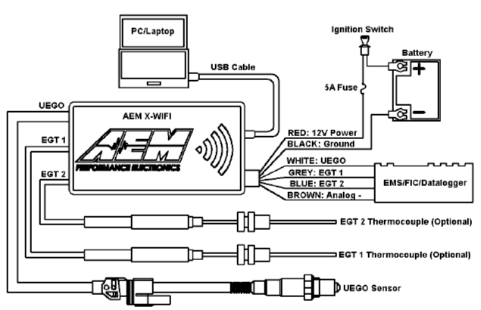

For the 10P analog cable, attach the black wire to the BLACK:Ground wire on the AEM Datalogger port, and the white wire from the 10P analog cable to the Grey: EGT 1, or Blue: EGT 2 on the AEM Datalogger port.
10P iTSX/LivewireTS - to BLACK:Ground
- to Grey: EGT 1 or Blue: EGT 2

For the 6P analog cable, attach the blue wire to the BLACK:Ground wire on the AEM Datalogger port, and the orange wire from the 6P analog cable to the Grey: EGT 1, or Blue: EGT 2 on the AEM Datalogger port.
6P X3 - to BLACK:Ground
- to Grey: EGT 1 or Blue: EGT 2

Single Channel Type K Thermocouple Amplifier TCA-MS-K-1
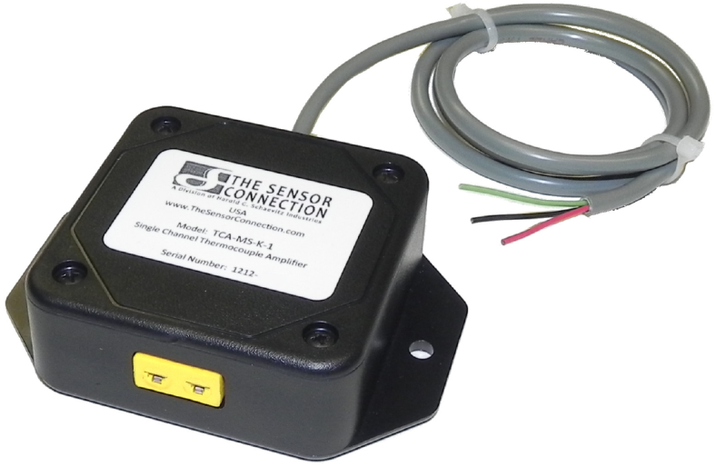
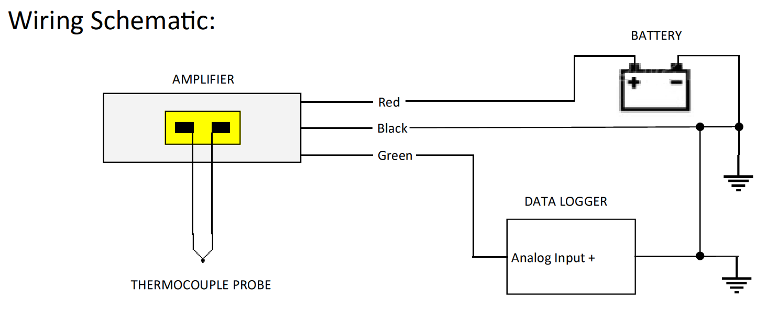
For the 10P analog cable, attach the black wire to the Black wire on the amplifier, and the white wire from the 10P analog cable to the Green wire on the amplifier.
10P iTSX/LivewireTS - to Black
- to Green

For the 6P analog cable, attach the blue wire to the Black wire on the amplifier, and the orange wire from the 6P analog cable to the Green wire on the amplifier.
6P X3 - to Black
- to Green
EGT Thermocuple Amplifier Single (1) Channel
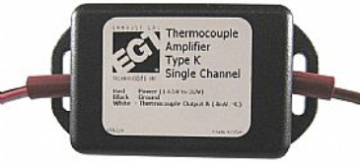
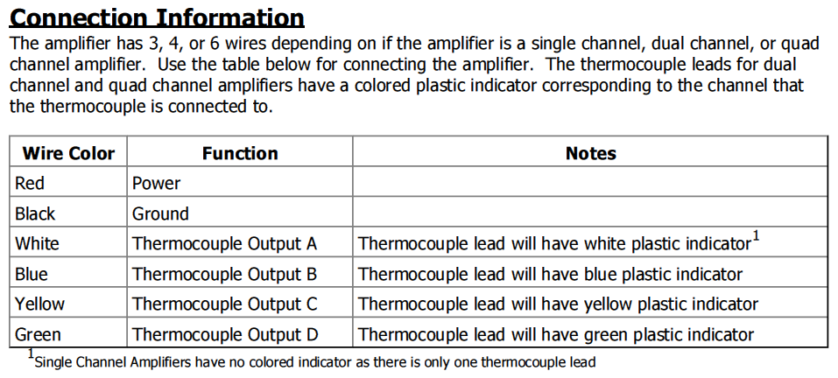
For the 10P analog cable, attach the black wire to the Black wire on the EGT device, and the white wire from the 10P analog cable to the White wire on the EGT device.
10P iTSX/LivewireTS - to Black
- to White

For the 6P analog cable, attach the blue wire to the Black wire on the EGT device, and the orange wire from the 6P analog cable to the White wire on the EGT device.
6P X3 - to Black
- to White
PCH with Pyrometer Lead Part# 40390 Bully Dog
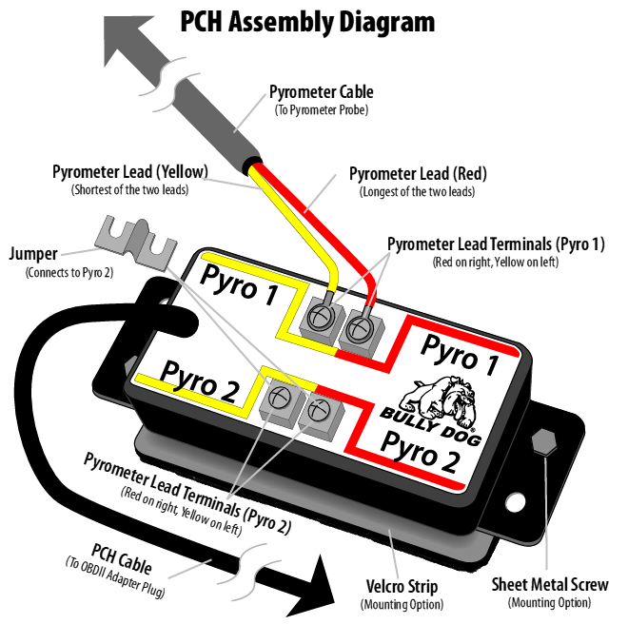
For the 10P analog cable, attach the black wire to the Black wire on the Bully Dog device, and the white wire from the 10P analog cable to the White wire on the Bully Dog device.
10P iTSX/LivewireTS - to Black
- to White

For the 6P analog cable, attach the blue wire to the Black wire on the Bully Dog device, and the orange wire from the 6P analog cable to the White wire on the Bully Dog device.
6P X3 - to Black
- to White

